TASK COMPLETION REPORT

Responsive Product Card Design
CSS Media Queries at 600px, 900px and 1200px

1. Objective
To improve the readability and presentation of a product card across different viewport sizes by using CSS media queries to adjust typography and spacing at three specified breakpoints.

2. Implementation Summary
The product card displays a wireless-headphones image, product name, short description, price, and a purchase button. Responsive CSS rules are used to adapt the card layout and spacing as the viewport changes.
Viewport range | Observed / intended styling | Purpose
Up to 600px | Compact layout; 12px padding and 14px base text (where configured) | Fit narrow mobile screens
601px–900px | 16px padding and 15px base text | Comfortable tablet spacing
901px–1200px | 20px padding and 16px base text | Roomier medium/desktop layout
Above 1200px | Default card styles apply | Maintain the desktop baseline

3. Testing Evidence
The screenshots below show the product card being inspected in Chrome Developer Tools at viewport widths of 600px, 900px and 1200px. The Styles panel shows the corresponding CSS rules being applied. The screenshots are included as supplied evidence.
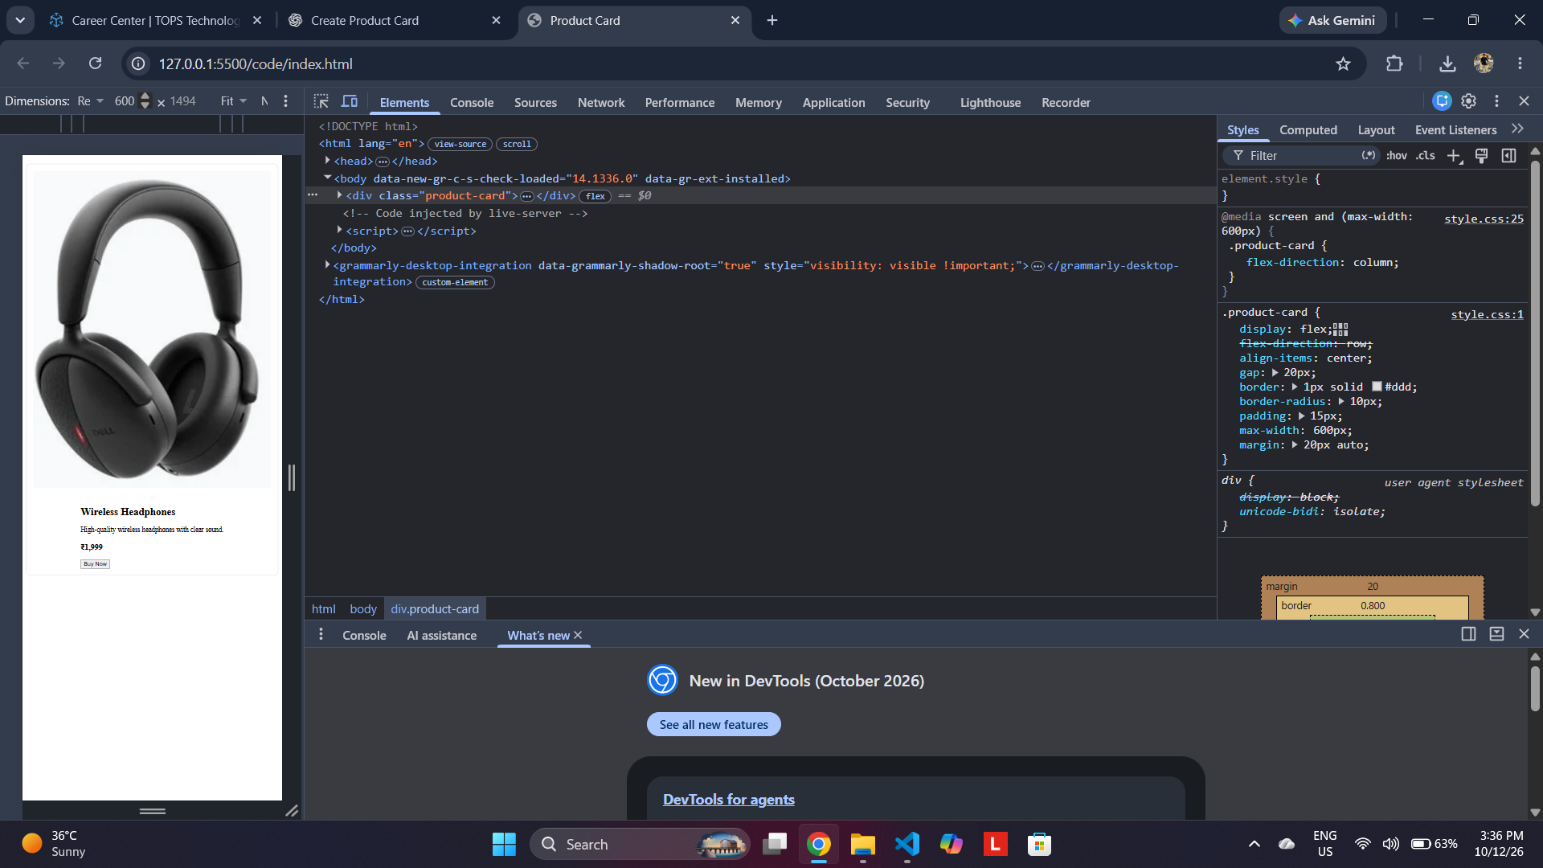
Figure 1. Viewport set to 600px

The mobile breakpoint is visible in the Styles panel. The card is displayed in a narrow viewport.
Figure 2. Viewport set to 900px
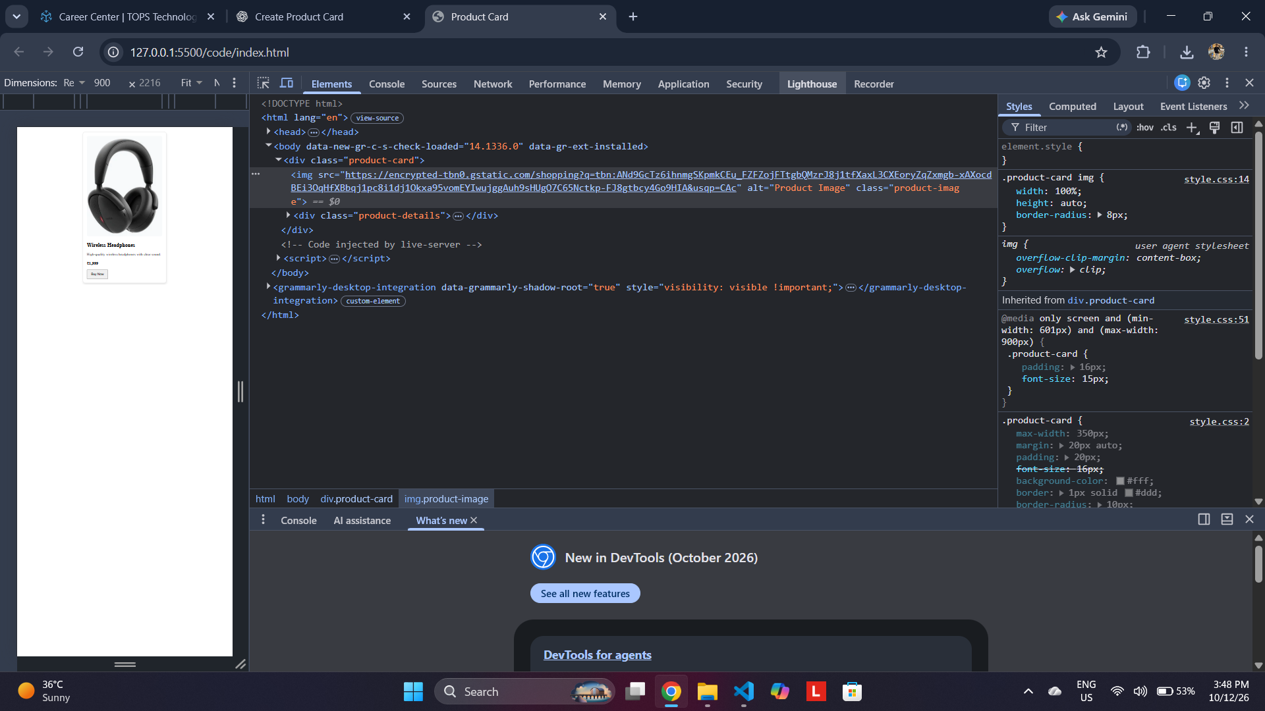
The 601px–900px media query is shown with 16px padding and 15px font size.
Figure 3. Viewport set to 1200px
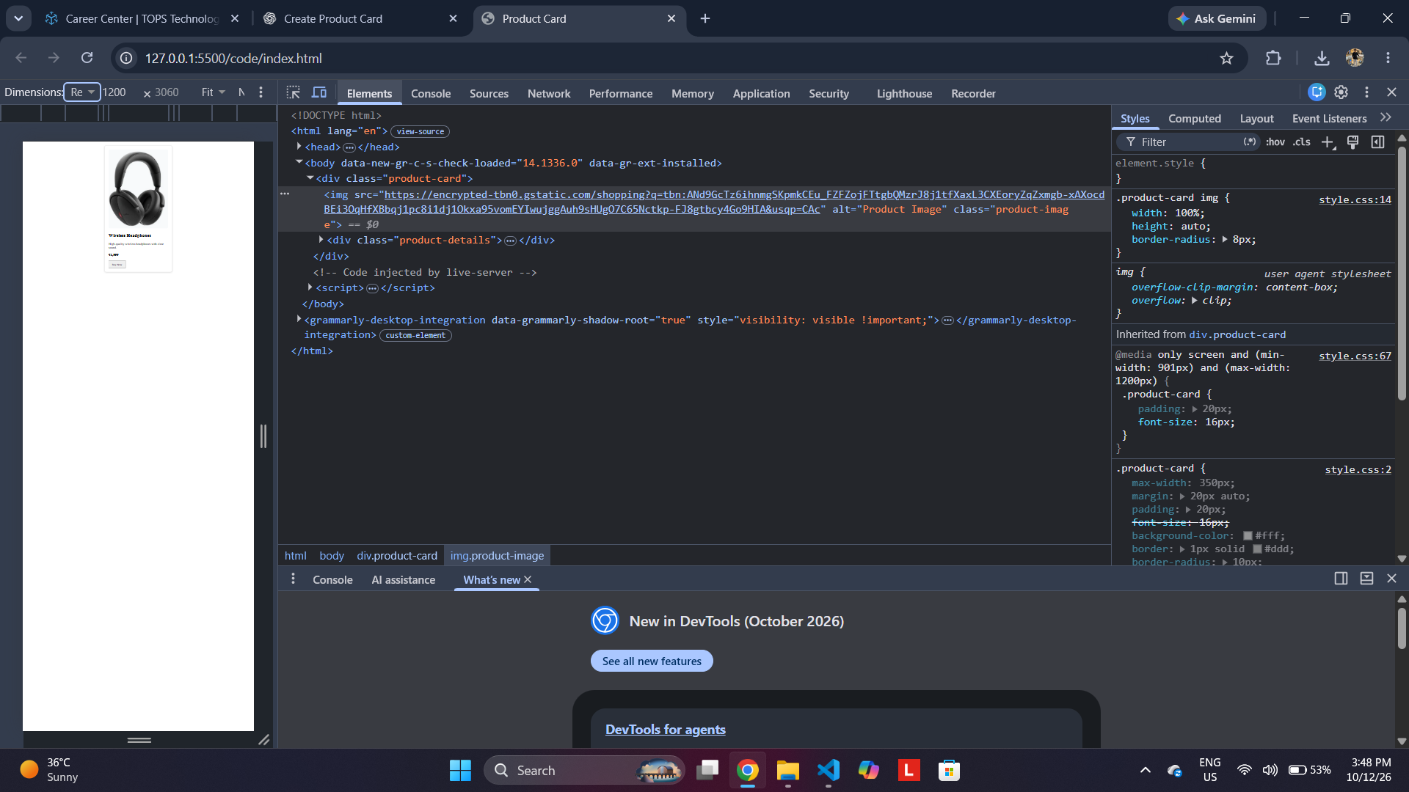
The 901px–1200px media query is shown with 20px padding and 16px font size.

4. Result
The product card was reviewed at the three requested viewport widths. The screenshots provide visual evidence of the responsive layout and the active media-query styles.

5. Conclusion
The task demonstrates responsive styling with CSS media queries. For the final submission, ensure that each breakpoint has a distinct and intentional font-size and padding rule, and test the exact boundary widths (600px, 900px and 1200px) in the browser.

